Avalanche Pulse Generator Notes

# Kerry Wong Design

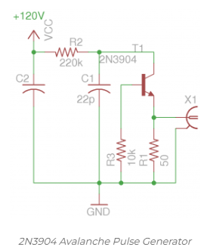

<http://www.kerrywong.com/2013/05/18/avalanche-pulse-generator-build-using-2n3904/>

# Can it be built on a solderless breadboard?

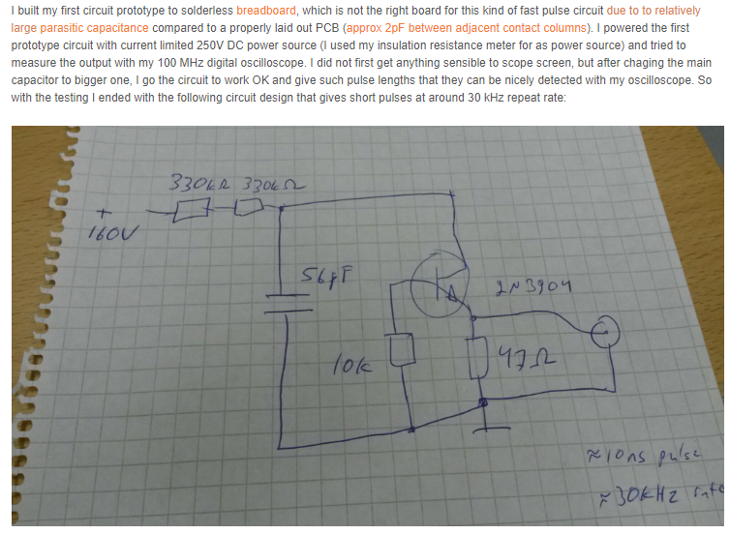

<https://www.epanorama.net/newepa/2016/11/17/avalanche-pulse-generator-circuit/>

# Can this pulse generator work with a Scope 1Mohm Input Impedance and 10x Scope Probe or do I need straight Coax with 50ohm termination or something to that effect?

Yes, IMSAI Guy demonstrates this with a 10Mohm input scope and a variety of scope leads.

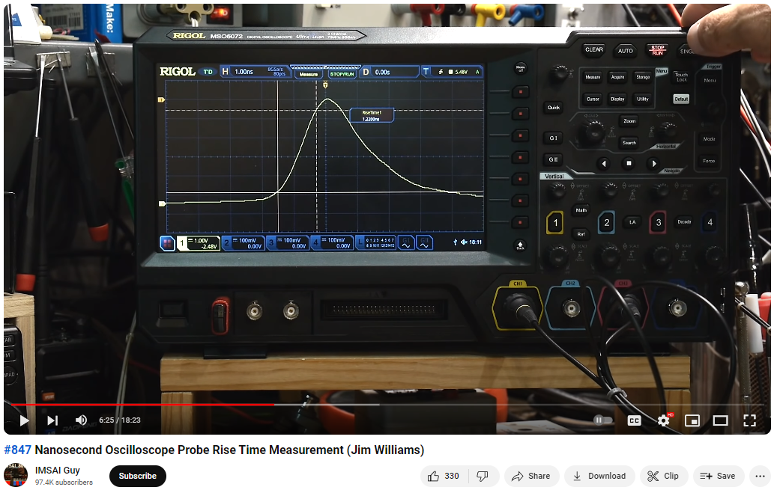

# What finally worked for me:

## Circuit -



+160V

100p

## Breadboard Circuit –

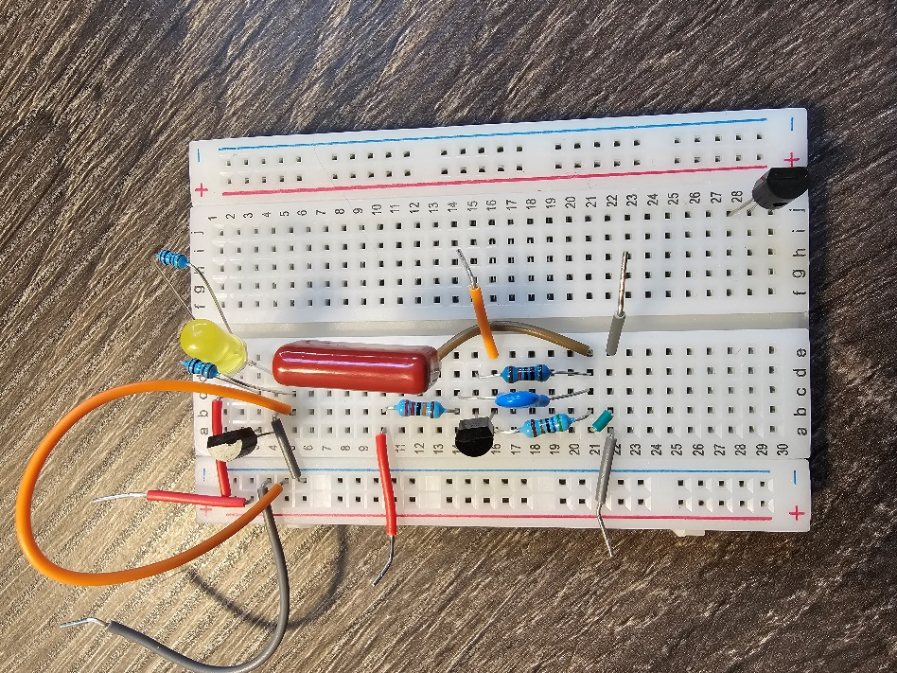

1. Be sure to use Capacitors rated for the Input Voltage you’ll be using. I figured that one out pretty quickly when I turned one of them black.
2. The separate circuit at the top of the breadboard is just a normally operating transistor/led circuit so I could periodically check if my transistors were still working. Power the circuit with 5V and tap the orange wire on and off of the +5V rail to turn the transistor base and LED on and off.

## Input Voltage Power Supply –

Low Voltage DC Supply – I used my Wanptek DC Supplies set to 28V, though the Boost converter I used could support a DC Input as low as 10Vdc. <https://a.co/d/4NL2bzU>

DC/DC Boost Converter - 8V-32V to ±45V-390V Step-up Converter <https://a.co/d/53m9fIH>

## Scope Waveforms –

### Baseline Established for Comparison, using Schmitt Trigger Pulse Generator and 10x Scope Probe. Note that for this test, the 10x scope probe was faster than the 1x scope probe, BNC to BNC coax, or coax with 50ohm termination. Note how the peak voltage changes for each Scope Configuration.

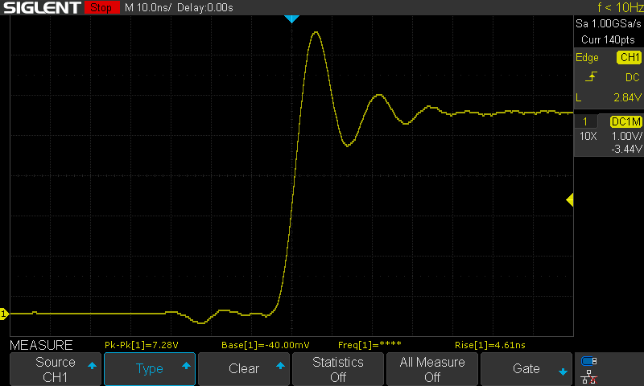

### 10x Scope Probe

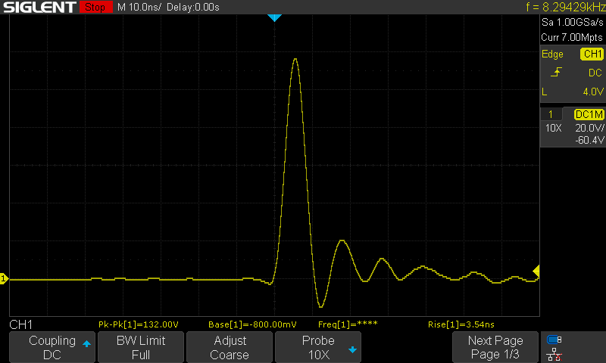

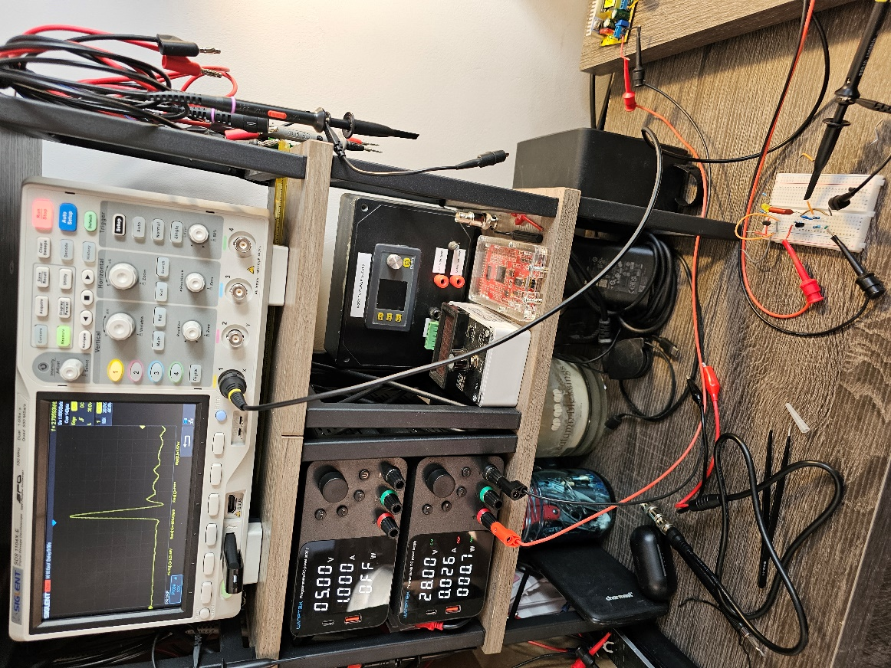

#### Zoomed out to demonstrate the desired Circuit Oscillation

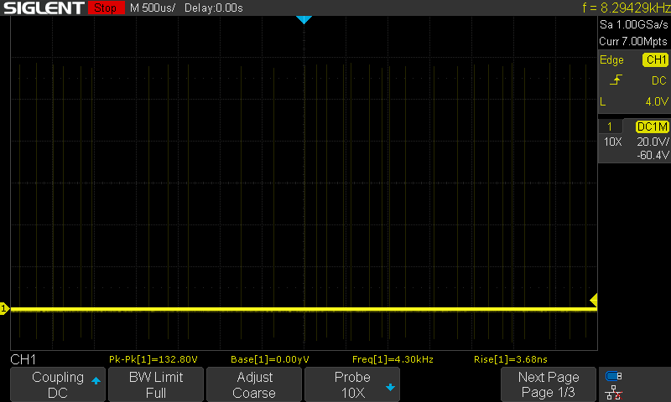

### 1x Scope Probe

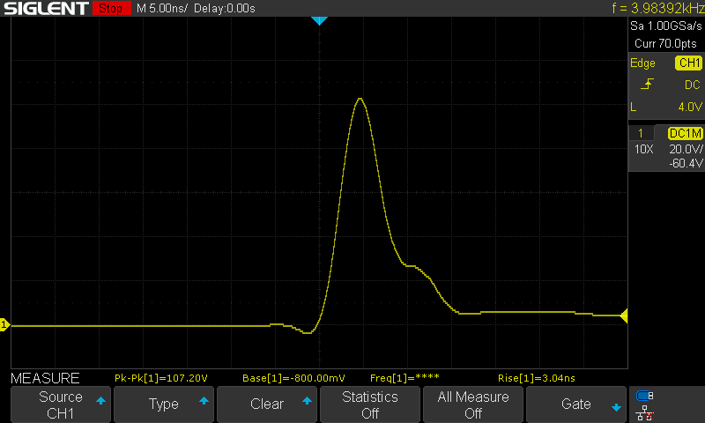

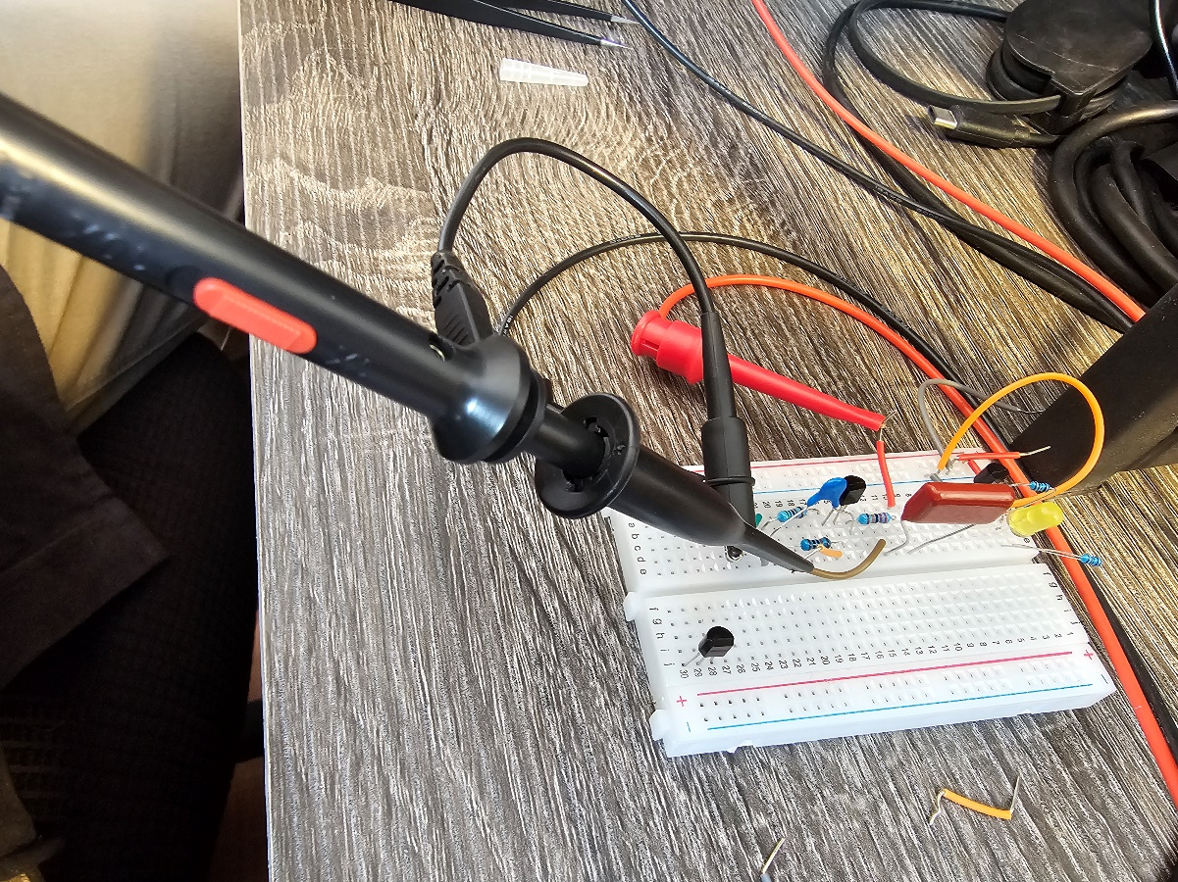

### Coax (High Impedance Input)

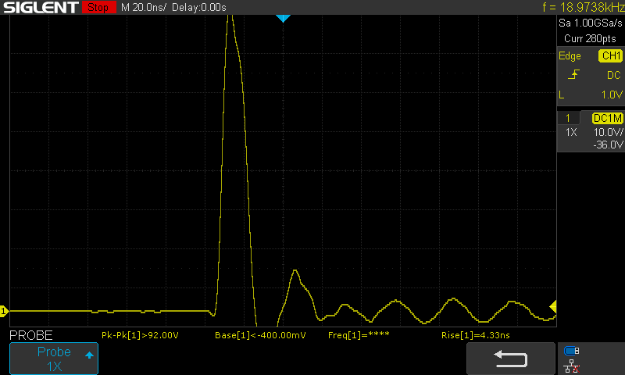

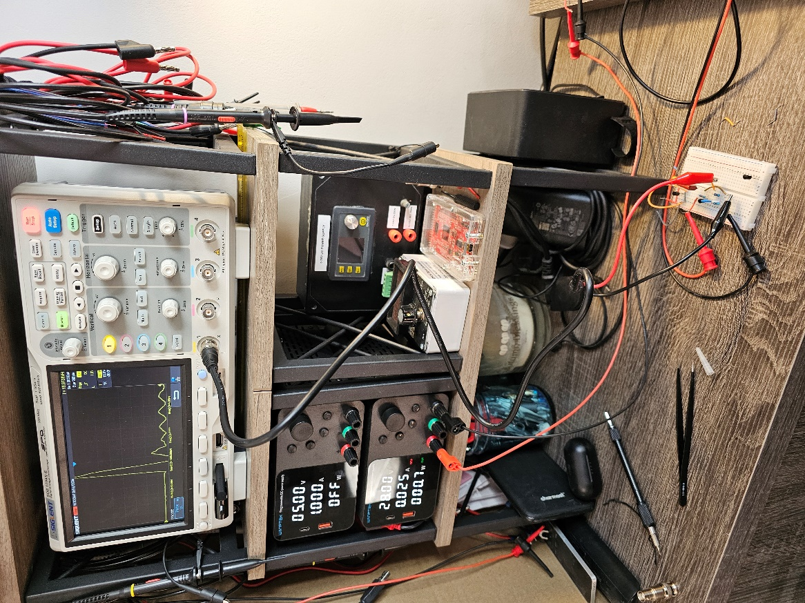

### Coax with 50 Ohm Termination Passthrough BNC Adapter

